I233018
LAB11
OS LAB

Question1 :
CODE:
#include <stdio.h>
#include <pthread.h>

//global VARS
int ADD_RESULT = 0;
int SUB_RESULT = 0;
int DIV_RESULT = 0;
int MUL_RESULT = 0;

int NUMBER_1 = 20;
int NUMBER_2 = 10;

//Functions for calc
void* addition (void * args)
{
ADD_RESULT = NUMBER_1 + NUMBER_2;
return NULL ;
}

void* subtraction (void * args)
{
SUB_RESULT = NUMBER_1 - NUMBER_2;
return NULL ;
}

void* multiply (void * args)
{
MUL_RESULT = NUMBER_1 * NUMBER_2;
return NULL ;
}

void* division (void * args)
{
DIV_RESULT = NUMBER_1 / NUMBER_2;
return NULL ;
}

int main()
{
printf("Number 1: %d\nNumber 2: %d\n",NUMBER_1,NUMBER_2);

pthread_t thread1 , thread2 , thread3 ,thread4;

pthread_create(&thread1,NULL,addition,NULL);
pthread_create(&thread2,NULL,subtraction,NULL);
pthread_create(&thread3,NULL,multiply,NULL);
pthread_create(&thread4,NULL,division,NULL);

pthread_join(thread1,NULL);
pthread_join(thread2,NULL);
pthread_join(thread3,NULL);
pthread_join(thread4,NULL);

printf("\nResults :\nAddition :%d\nSubtraction: %d\nMultiplication :%d\nDivision :%d\n",ADD_RESULT,SUB_RESULT,MUL_RESULT,DIV_RESULT);

return 0;
}
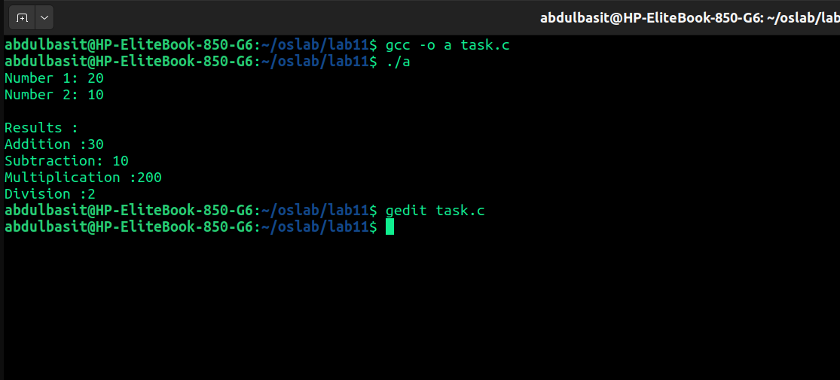
Q2:
CODE
#include <stdio.h>
#include <pthread.h>
#include <math.h>

//Struct to store data

struct DATA {
int number;
double result;

};

//Functions for calculations
void* squareRoot (void * args)
{
struct DATA * temp = (struct DATA *)args;
// printf("%d",temp->number);
temp -> result = sqrt(temp -> number);
return NULL ;
}

void* square (void * args)
{
struct DATA * temp = (struct DATA *)args;
temp -> result = temp -> number * temp -> number;
return NULL ;
}

int main()
{
printf("Number is 16\n");

struct DATA sq , sqrt;
sq.number = 16;
sqrt.number = 16;
sq.result = 0;
sqrt.result= 0;

pthread_t thread1 , thread2;

pthread_create(&thread1,NULL,squareRoot,(void *)&sqrt);
pthread_create(&thread2,NULL,square,(void *)&sq);

pthread_join(thread1,NULL);
pthread_join(thread2,NULL);

printf("Results:\nSquare : %f\nSquare Root: %f\n",sq.result,sqrt.result);
return 0;
}

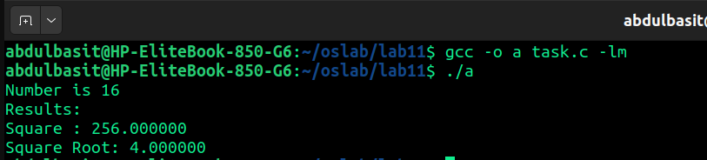

Q3:
CODE:
#include <stdio.h>
#include <pthread.h>

void * threadInfo (void * args)
{
//cast as struct
pthread_attr_t * attr = (pthread_attr_t *)args;

printf("The Thread ID is : %zu\n",pthread_self());

//Print other Attrs
size_t stackSize;
int policy;

pthread_attr_getstacksize(attr,&stackSize);
pthread_attr_getschedpolicy(attr,&policy);

printf("Stack Size: %zu\n",stackSize);

printf("Scheduling policy: ");
switch (policy)
{
case SCHED_FIFO: printf("SCHED_FIFO\n"); break;
case SCHED_RR: printf("SCHED_RR\n"); break;
case SCHED_OTHER: printf("SCHED_OTHER (default)\n"); break;
default: printf("Unknown\n"); break;
}
return NULL;

}
int main()
{
//initialize thread
pthread_t t1;

//create attr struct
pthread_attr_t t1_attr;

//initialize struct obj
pthread_attr_init(&t1_attr);

//set stack size as 3 mb
pthread_attr_setstacksize(&t1_attr,3*1024*1024);

//set schedule policy as FIFO
pthread_attr_setschedpolicy(&t1_attr,SCHED_FIFO);

//set thread as join
pthread_attr_setdetachstate(&t1_attr,PTHREAD_CREATE_JOINABLE);

// create thread
pthread_create(&t1,&t1_attr,threadInfo,&t1_attr);

//wait for thread to finish
pthread_join(t1,NULL);

//Free up struct space
pthread_attr_destroy(&t1_attr);

return 0;
}
